**Lead List Panel  
  
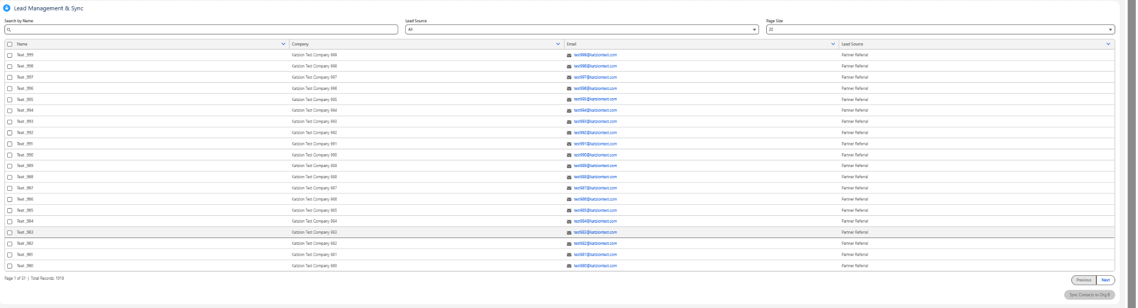**  
1) Search Leads by Name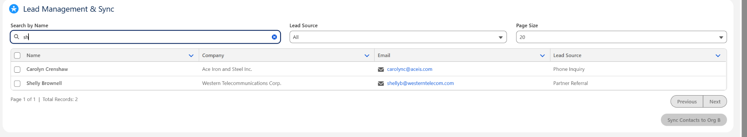  
  
2) Search Leads by Lead Source  
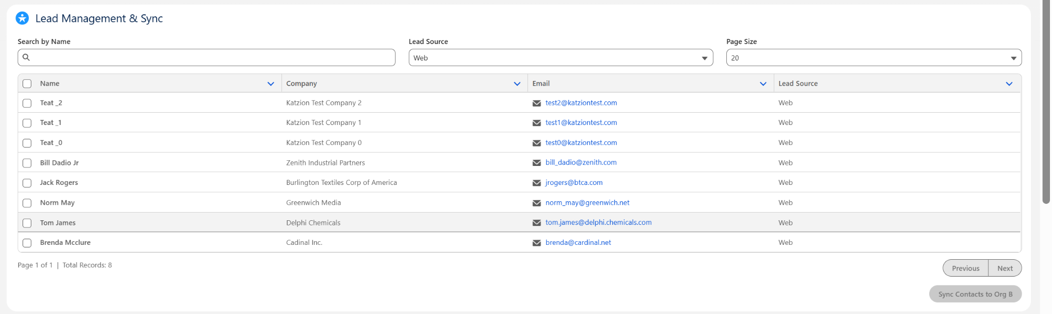  
  
3) Page size is configurable.  
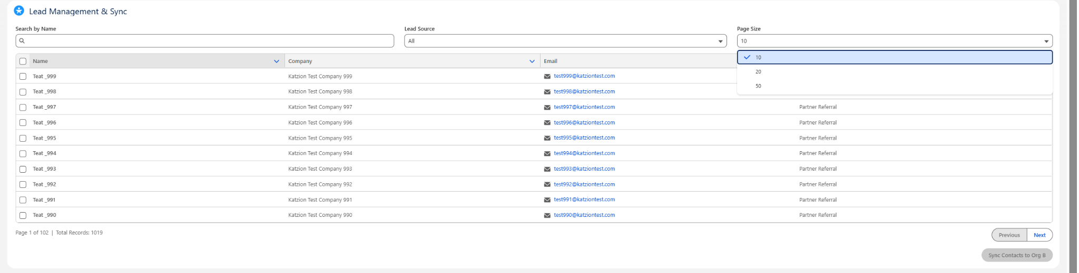

4) We can select multiple records from different pages.  
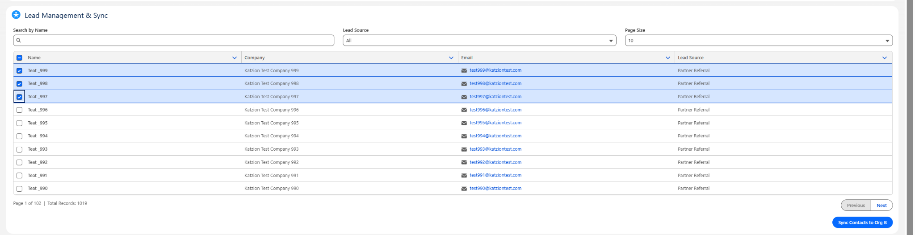

5) We can select multiple records and sync them to OrgB.  
